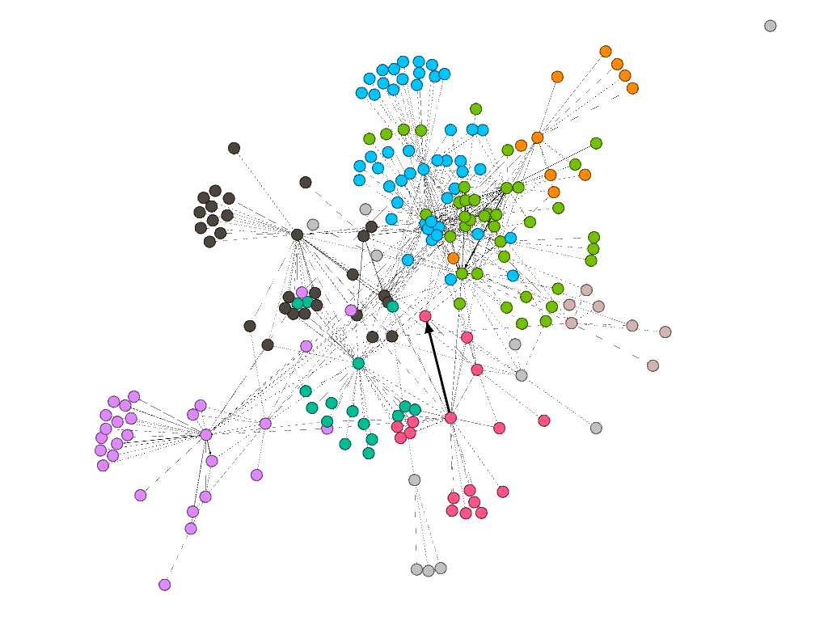

Shaping and Joining of Plastics

Climate Change Mitigation Technologies Used In Processing and Production

Protective Sports Garments

Manufacturing of Electrical Components

Material Analysis (Use of Electric, Electric-Chemical, Magnetic Means)

Layered Products

Armor

Semi-Conductors

Metal or Metal Oxide Catalysts

Macromolecular Compounds Involving C-C Bonds (Isocyanates, Ether Links, After Treatments, Compounding Ingredients)

Generation, Conversion, Distribution of Electric Power

Ceramics